Poor Customer Relationship
Student’s Name
Course Name and Number
Instructor’s Name
Date

Poor Customer Relationship
Inefficiency is a common concept in the world of business. Inefficiency can be described as a failure to attain maximum productivity in a certain field or area of operation. Businesses have various sections as well as fundamental drivers. Some of these aspects include capital management, customer relationship, employee development, logistics management, product development, and technology management, among others. Inefficiencies in the above areas can greatly undermine an organization's growth. Some of the impacts of inefficiency include reduction in quality of products and services, destruction of morale, and waste of organization's resources (Horton et al., 2019). These resources entail all materials that are utilized to achieve a given organization’s objective. This paper will examine poor customer relationships as an inefficiency in the selected organization and also provide new approaches to solve this issue.
Customer relationship is a concept that describes the nature of interactions between customers and businesses (Dewnarain, Ramkissoon & Mavondo, 2019). Most businesses have the department of customer relations that is concerned with the assessment of the association between customers and the company. For instance, this department handles customer complaints and other emerging issues that might affect the company's reputation and productivity at large. Businesses globally are not expected to underestimate the impacts of positive customer experience.
Based on the day-to-day experience as an employee in this organization, it is apparent that it lacks a good customer relationship. Various processes depict that the relationship between customers and the business is poor. This business has generally failed to attain the expectations of its customers. These expectations cut across issues such as response time, overall experience, and service quality, among other core issues. These issues are discussed below.
One of the reasons why this organization is associated with poor customer relationships is based on the response time. It is evident that this organization puts clients on hold for a long time. Generally, the customer call service in this organization is not efficient because customers are forced to hold for log when making calls. One of the reasons why customers are forced to hold for an extended time is that this organization lacks adequate personnel in this department. Only a few individuals are assigned in this area hence making it difficult to respond to many clients in a short span. Along the same lines, customers' emails and text messages take long before they are replied to.
This organization also has a poor customer relationship because callers are transferred again and again. The act of transferring calls more than once is quite annoying. Most clients have raised complaints regarding this issue because they waste a lot of time without a meaningful response. These customers are bounced from one call agent to another. One of the reasons for such transfers is that an agent might lack adequate knowledge or experience that is required to respond to the customer’s needs or questions. Therefore, he or she opts to transfer the caller to the next available agent. All these imply that the organization has a poor communication system that is not client-oriented.
Another issue is that some employees lack a sense of empathy. Some employees fail to show empathy when responding to customers. For instance, some agents are never sorry when clients report a serious issue that relates to issues such as faulty products. The customers' who experience such issues might feel that the company does not care about their well-being and satisfaction. This aspect is also connected to rude behavior among employees. Some agents are quite rude. They do not portray professionalism at all. For instance, they do not greet the caller. Another bad behavior is failure to introduce themselves. Lastly, some customers provide poor ratings because they feel that they were given inaccurate or wrong information. Therefore, this business should address these inefficiencies as soon as possible since such aspects compromise its competitive advantage.
This business should integrate several new approaches that would improve the efficiency of the customer relationship. One of the strategies to address this inefficiency is incorporating instant messaging. This business should offer live chats on their online segments. Customers will be confident when this aspect is implemented because they can easily contact the company at any time. Live chats ensure that there is instant messaging (Clark, 2019). Therefore, clients will be able to receive quicker feedback as compared to when making calls that might take longer to connect. Research also indicates that live chats improve customer satisfaction since their problems are solved faster. It is evident that live chats are even quicker than email or support tickets since these can take more hours or even days before receiving a response. Livechat is also more engaging as compared to other mediums. Apparently, live chats are less expensive as compared to phone support. For example, the business spends a lot of money on fixing the hardware and software of the phone support channel. Therefore, live chats are the best alternative for addressing the communication problem between clients and this company.
Another strategy that this business should utilize is the training of its customer support team. This team needs thorough training to improve certain skills. Through training, the team will acquire important elements such as active listening skills, positive language, empathy, persuasion, and positive language (Shen & Tang, 2018). Therefore, this training will improve the interaction between them and clients, thus boosting customers' experiences.
Based on the evaluation, it is important to evaluate the customer relationship of this business to determine the accuracy or effectiveness of the alternative strategies in solving this problem. This business should give clients an opportunity to give their reviews after being served. These reviews should be accompanied by ratings that range from a scale of one to ten. For instance, a rating of less than 4 shows that the business is still struggling with this inefficiency, while a rating of above 8 shows an improvement. The image below shows an example of customer feedback in relation to customer relationships (Shen & Tang, 2018).
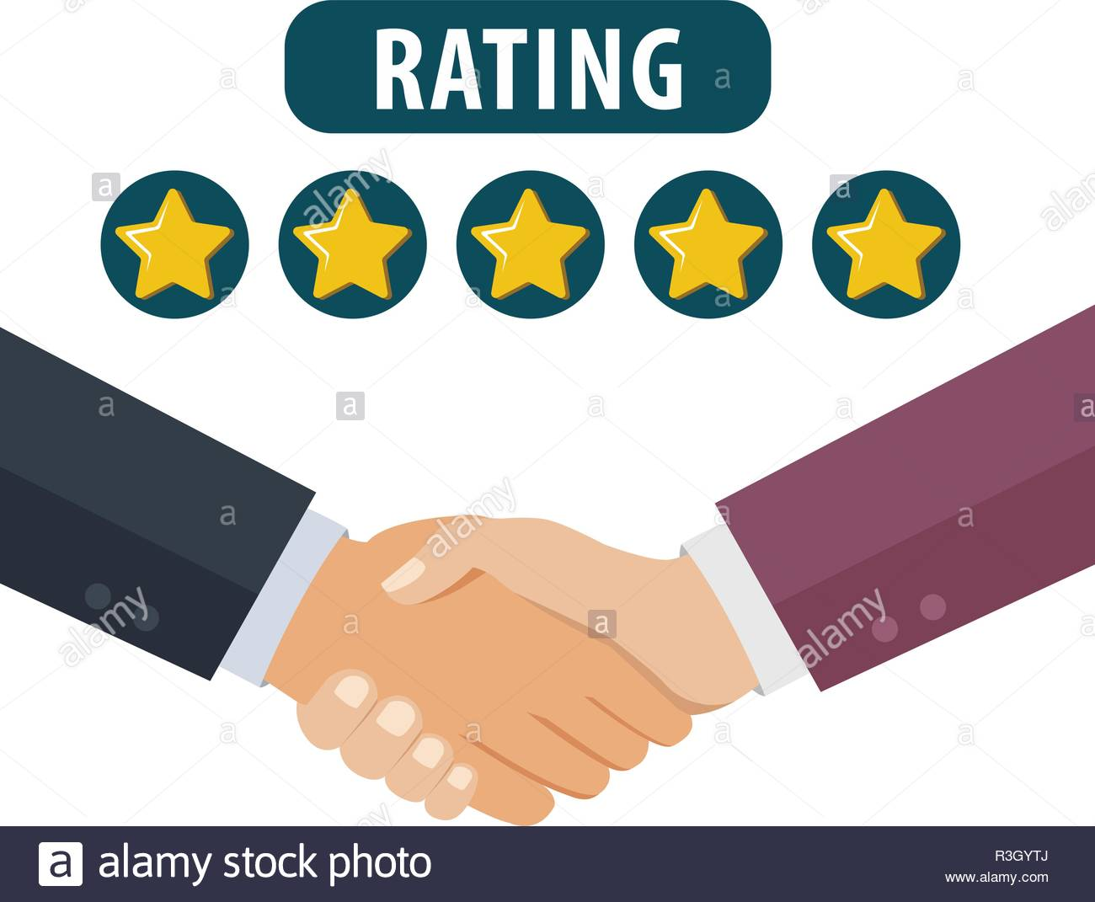
The above image shows that the customer is happy and fully satisfied with the business hence giving full stars rating.
In summary, this paper has explored inefficiency in customer relationships. This organization has a poor customer relationship due to various reasons. These reasons include longer response time and lack of empathy. The business should consider live chats and training of the customer support team to address this problem.

References
Clark, D. (2019). Why Live Chats is Important for Your Business. Retrieved 7/25/2020. From https://www.digitaldoughnut.com/articles/2019/september/why-live-chat-is-important-for-your-business
Dewnarain, S., Ramkissoon, H., & Mavondo, F. (2019). Social customer relationship management: An integrated conceptual framework. Journal of Hospitality Marketing & Management, 28(2), 172-188.
Horton, P., Bruce, R., Reynolds, C., & Milligan, G. (2019). Food Chain Inefficiency (FCI): accounting conversion efficiencies across entire food supply chains to re-define food loss and waste. Frontiers in Sustainable Food Systems, 3, 79.
Shen, J., & Tang, C. (2018). How does training improve customer service quality? The roles of transfer of training and job satisfaction. European management journal, 36(6), 708-716.

